CYB102 Project 4 (🔗 Instructions Page)

👤 Student Name: Shireen M
✉️ Student Email:

Reflection (Required)

🤔 Reflection Question #1: If I had to explain “what is a DoS attack” in 3 emojis, they would be…
(Feel free to put other comments about your experience in this unit here, too!)
🌊💻💀

🧠Reflection Question #2: What are some different types of DoS/DDoS attacks?
Volume-based attacks overwhelm a network by sending an enormous amount of unnecessary traffic, making it difficult or impossible for legitimate users to access the service. Examples include UDP Floods, ICMP Floods and Ping of Death attacks.

Protocol attacks take advantage of weaknesses in network protocols, particularly at Layers 3 and 4, to disrupt communication between systems. Common examples are SYN Floods, Smurf Attacks and Fragmentation Attacks.

Application layer (Layer 7) attacks target the applications or services that users interact with, such as websites. These attacks imitate normal user requests but send them in large numbers to overload the server. Examples include Slowloris, HTTP Floods and DNS Query Floods.

Amplification attacks work by sending small requests that generate much larger responses from other servers, causing a huge amount of traffic to be directed at the victim. DNS Amplification and NTP Amplification are well-known examples.

Distributed Denial-of-Service (DDoS) attacks are more powerful because they use a network of compromised devices, known as a botnet, to launch attacks from many locations at the same time. This makes the attack much harder to stop. The Mirai botnet is one of the most well-known examples of a DDoS attack.

📣 Shoutouts: Share appreciation for anyone who helped you out with this project or made your day a little better!
Huge shoutout to Claude (Anthropic's AI) for being incredibly patient with me through this whole project! Every time I hit an error like that reset_timeout_connection typo that broke my nginx config Claude walked me through it step by step without making me feel dumb about it. Also shoutout to whoever wrote the CodePath hints section, those AI opportunity callouts were actually really helpful for knowing when to ask for help.

Required Challenges (Required)

Nginx screenshot: A screenshot of your nginx config file(s) with your DoS mitigation rules implemented:
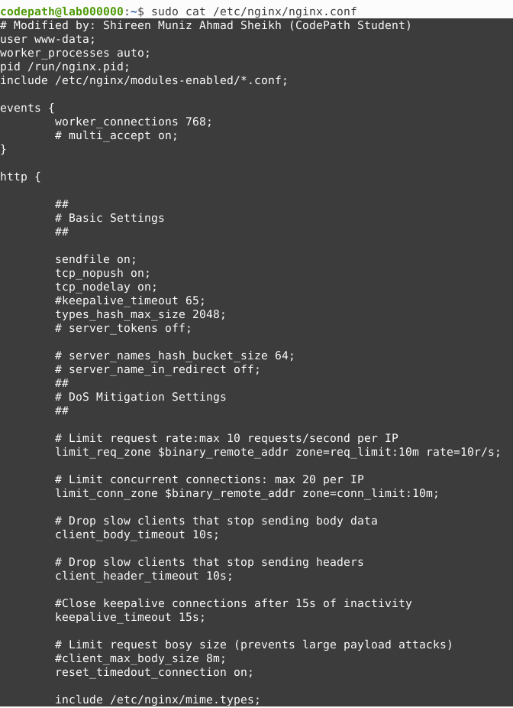

Unprotected screenshot: A screenshot of your Netdata TCP connections graph during the unprotected Slowloris attack:
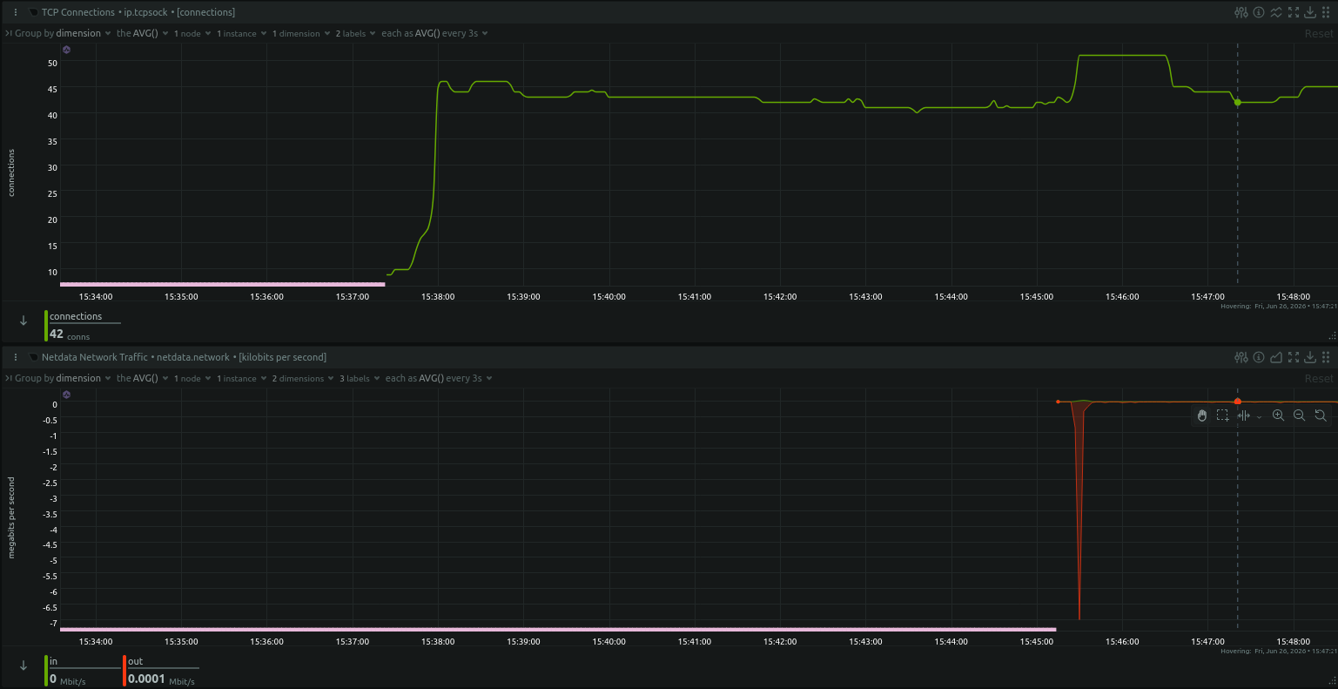

Protected screenshot: A screenshot of your Netdata TCP connections graph during the protected Slowloris attack
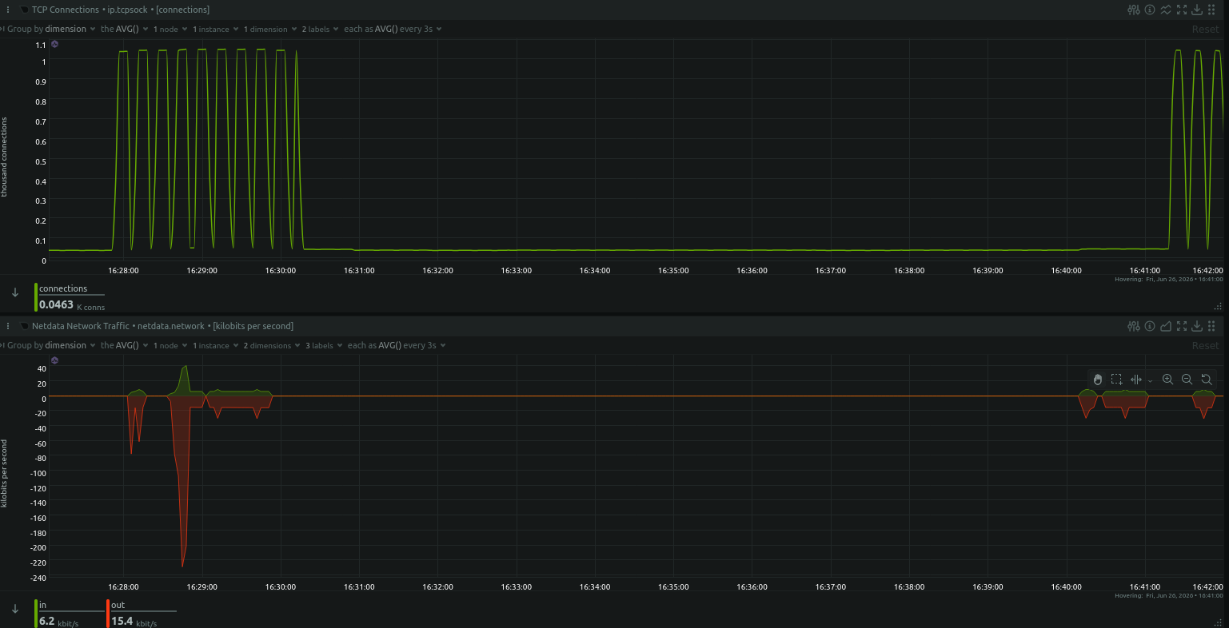
Note (Optional):

Explanation of Differences: An explanation of the differences between the unprotected and protected Slowloris attacks, in your own words:
So this was honestly the coolest part of the whole lab because you could actually see the difference in real time on the graphs.

During the unprotected attack, I ran Slowloris with 500 sockets and watched the Netdata TCP connections graph just... climb. It went from about 10 connections at baseline and shot straight up to around 46-50 connections the moment the attack started, and then just stayed there. Like a plateau. For the entire duration. nginx had no idea what to do it just accepted every single connection Slowloris opened and held onto them because there were no rules telling it not to. The server was basically paralyzed. What really surprised me was that the network traffic graph showed almost zero bandwidth usage the whole time. Slowloris wasn't sending much data at all, it was just holding connections open like someone putting their foot in a door.

During the protected attack, after I added the DoS mitigation rules to nginx, the graph looked completely different almost like a heartbeat monitor. Instead of that flat plateau, I got this rapid sawtooth pattern where connections would spike up to around 1,100 and then immediately crash back down to near zero, over and over again. What's happening there is nginx hitting those slow connections with the timeout rules I set client_header_timeout, reset_timedout_connection, limit_conn and just kicking them out before they can pile up. The server stayed alive and responsive the whole time because it was actively cleaning it instead of letting Slowloris squat on every connection.

The biggest lesson for me is Slowloris is dangerous not because of how much traffic it sends, but because of how many connections it can hold. And the fix isn't about bandwidth filtering, it's about teaching nginx to be impatient with slow clients.

Stretch Challenge (Optional)

Stretch Question: A detailed explanation of how you know which .pcap file is from the vulnerable server, and which is from the server with DoS mitigation set up:
When I first opened both files in Wireshark I honestly wasn't sure what I was looking for, but once I applied the tcp.flags.reset==1 filter it became really obvious really fast.

A.pcapng is the protected server. The moment I scrolled through the packets in file A, I was met with literally thousands of [RST] packets all coming from port 80 back to different ports, all with Win=0, Len=0. That's nginx slamming the door on every Slowloris connection that was being too slow. The I/O graph for file A also showed that spiking pattern repeated every ~15 seconds, which matched exactly what I saw on my Netdata dashboard during the protected attack. The tcp.flags.reset==1 filter returned massive results.

B.pcapng is the vulnerable server. This one was actually confirmed by what was missing rather than what was there. When I applied tcp.flags.reset==1 to file B, I got zero results completely empty. nginx never sent a single RST packet. Every connection Slowloris opened just got accepted and sat there. The I/O graph showed one big spike and then mostly flat activity, which makes sense the connections were being held open rather than constantly reset and reopened. No RSTs means no protection.

So the way I remember it, RST packets = protected (nginx fighting back), no RST packets = vulnerable (nginx just taking the hit). It's kind of like the difference between a bouncer at a club who kicks out people who aren't ordering anything, versus a venue with no staff that just lets everyone stand around until the place is too crowded for paying customers to get in.

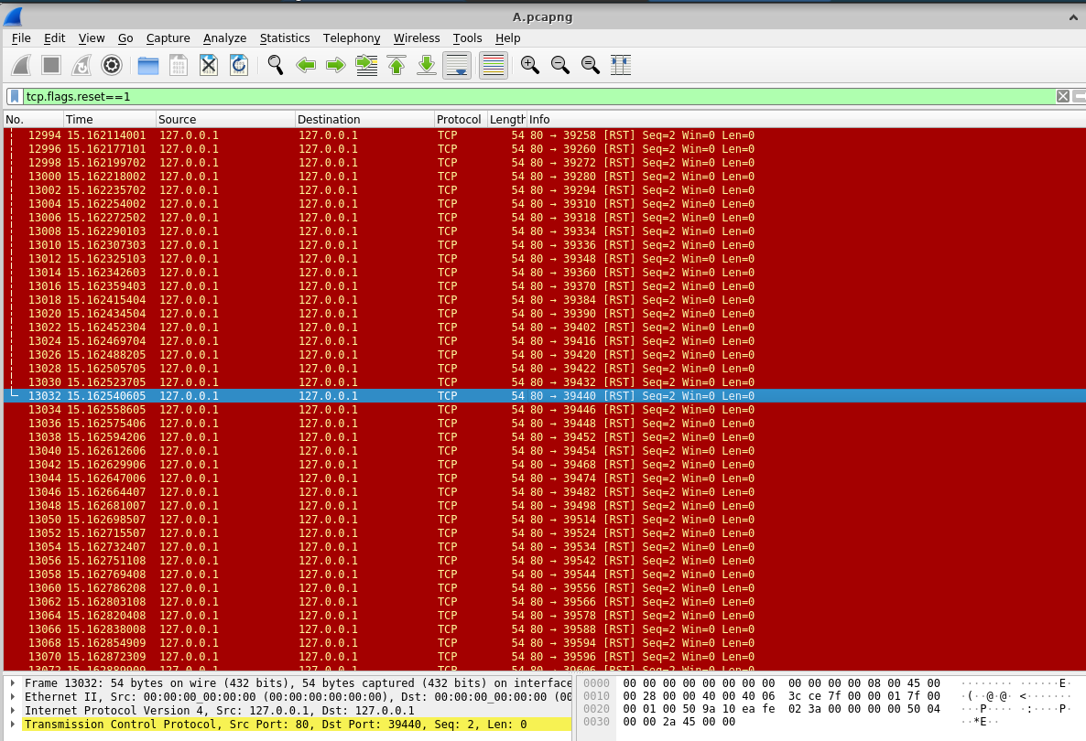

Submission Checklist
👉Check off each of the features you have completed. You will only be graded on the features you check off.

Required Challenges
- Nginx Screenshot
- Unprotected Screenshot
- Protected Screenshot
- Explanation of Differences

Stretch Challenge
- Stretch Question

💡Tip: You can see specific grading information, including points breakdown, by going to 🔗 the grading page on the course portal.

